**BRAC UNIVERSITY**

**Department of Computer Science and Engineering**

**CSE420: Compiler Design**

**Quiz 01, Fall 2015**

**Duration: 1.00 hours, Total Marks: 35**

**Student Name:**

**Student ID:**

**Section:**

1. Draw the basic block diagram of Compilation Process. [5]
2. State the issues driving Compiler Design. [2]
3. Convert RE **(a + ba)a** to NFA using Thompson’s Construction. [6]
4. Convert following NFA to DFA using Subset Construction method. [3]

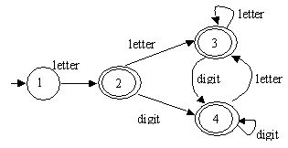

5. Convert following DFA to RE : [3]

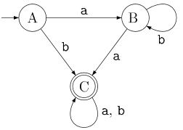

6. Draw the syntax tree of RE **((ab)|(ba))\*** and determine the first-pos and last-pos of each node. [6]